Bonus Assignment | Section - A | OS Monsoon’2025
Group ID: 16
Members:
- Vaibhav Samrat Waghaye | 2024597
- Rigzin Gyalpo | 2024458
Contributions
- Vaibhav: grep, wcl, MLFQ scheduler
- Rigzin: MLFQ Scheduler
Part 1: Grep & WCL Commands
Grep Command
- Usage: grep PATTERN FILE
- Takes exactly 2 arguments: a search pattern and a filename
- Uses dir_lookup() to get the file inode number
- Reads the entire file using file_read() in blocks
- Searches for lines containing the pattern
- Prints all matching lines
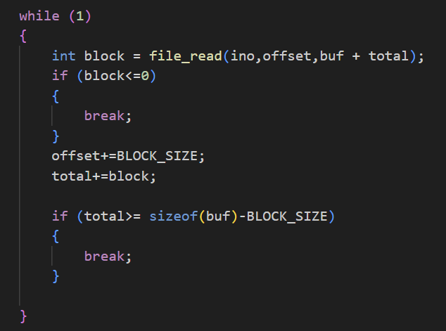
WCL Command
- Implemented line counting utility (wcl.c)
- Reads files using dir_lookup() and file_read()
- Counts \n characters and prints total
- 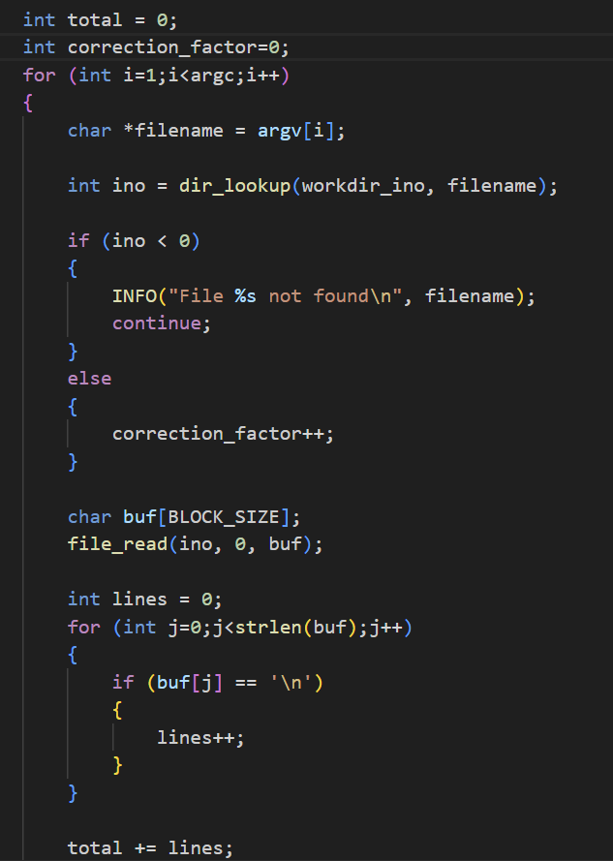
The correction factor is interesting because it adds only if the file exists
Part 2: MLFQ Scheduler
Files Modified
- process.h: Added fields for MLFQ levels, timestamps, and statistics
- process.c: Implemented 4 functions:
  - proc_alloc(): Initialize process with level 0, timestamps
  - proc_free(): Print lifecycle statistics on termination
  - mlfq_update_level(): Demote processes based on CPU usage
  - mlfq_reset_level(): Boost priorities every 10s and on keyboard input
- kernel.c: Modified 2 functions:
  - intr_entry(): Count timer interrupts
  - proc_yield(): Schedule highest priority process, update statistics
MLFQ Rules Implemented
- Rule 1: Schedule lowest level # (highest priority) first
- Rule 3: All processes start at level 0
- Rule 4: Processes move down after using time quantum (100ms, 200ms, 300ms, 400ms, 500ms)
- Rule 5: Boost all processes every 10 seconds; boost shell on keyboard input
Edits were made in the places required
Test Case-
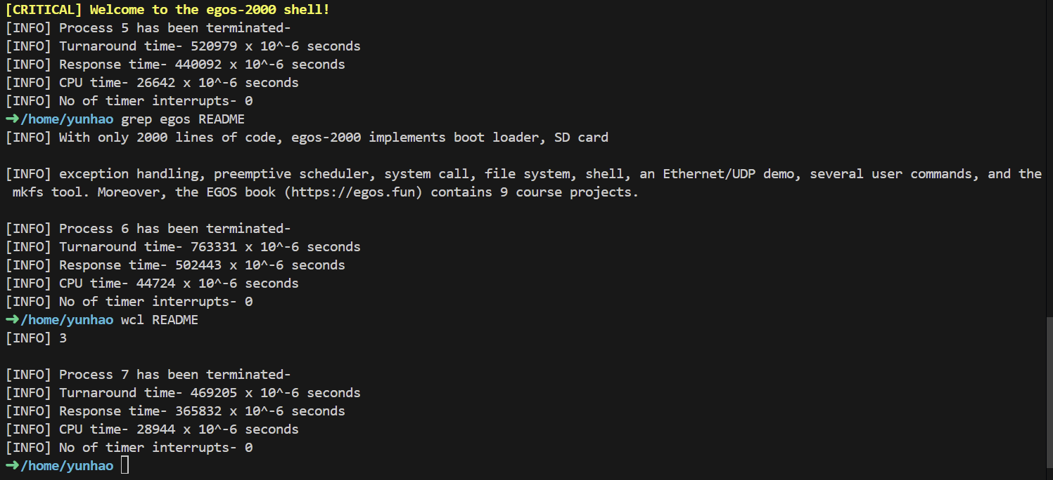

Github- https://github.com/vaibhavsw27/OS-Bonus-EGOS-2000

